Personal Information
Welder Name, Surname
ID Number
Date And Place Of Birth
Telephone/E-Mail
Address

Person Information To Be Reached In Emergency
Name, Surname
Telephone Number

In Case Of A Company Application, Company Informations
Company Name
Company Address
Company Telephone
Company E-Mail

Application Information
Written Exam Request | YES NO
Application Type | First Certification Certificate Renewal Exam Repetition
Will The Applied Personnel Record Be Approved In Accordance With 2014/68/EU Regulation Annex 3.1.2? | YES ☐ / NO ☐
Do you know the risk and hazard dimensions of the welded procedures you will carry out within the scope of approval of Annex 3.1.2 Of Regulation 2014/68/EU and accept the certificate responsibility? | YES ☐ / NO ☐

Scope / Reference Of Requested Qualification
TS EN ISO 9606-1 | API 1104 | AWS D 1.1
TS EN ISO 9606-2 | ASME SEC IX | AWS D 1.2
TS EN ISO 9606-3 | TS EN ISO 13585 | AWS D 1.5
 | TS EN ISO 14732 | AWS D 1.6
Welding Method
Manual Metal Arc Welding – 111 | MIG Welding With Solid Wire Electrode -131
MAG Welding With Solid Wire Electrode – 135  MAG Welding With Flux Cored Electrode - 136 | Submerged Arc Welding With Solid Wire Electrode (Partly Mechanized) -121  Brazing - 901
TIG Welding With Solid Filler Material (Wire/Rod) - 141 | OTHERS ( ………………………………….)
Requested Welding Position
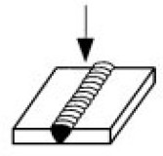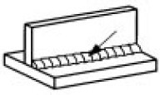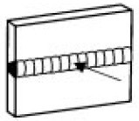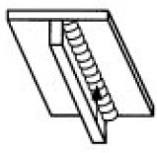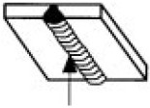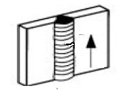
PA PB PC PD PE PF
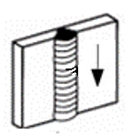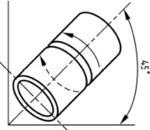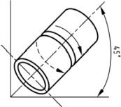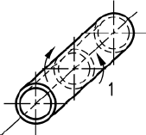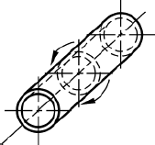
PG H-L045 J-L045 PH PJ

Welding Details
Product Type | Welding Details | Material Thickness /Diameter | Welding Details | FILLER MATERIAL
Butt Weld (BW) | Single Side | T ( Thickness ): …………………… | Plate (P) | FM1 FM4
Fıllet Weld (FW) | Both Side |  | Pipe (T) | FM2 FM5
 | Single Layer | D ( Pipe Outside Diameter ): ……….. | With Material Backing | FM3 FM6
 | Multi Layer |  | Without Material Backing
Information
SZUTEST does not provide consultancy services to the applicant under the relevant certification; If it provides training service, the personnel used in the training service is not assigned to the examination program. It informs the candidate about the application, exam plan, exam result, surveillance and document validity process via SMS and / or e-mail. During the certification program and the validity of the document, makes the FR.P.17 Document Usage Contract that will be valid for determining the rights and obligations that the parties have and if they are entitled to receive the certificate. In the event that it is entitled to receive a certificate, it publishes the Name, Surname, Document Type and Reference number of the Certified Person during the validity period of www.szutest.com.tr. The applicant, the information about the exam and certification, for the Welding Staff (Welder, Welding Operator, Brazer) - to the Procedure for Resource Staff Certification Program According to PR.PB.07 International Standards and You can call +90 216 469 46 66 and reach the Personnel Certification section to learn.
As the applicant, I accept and undertake that I will comply with the conditions stated in the PR.PB.07 International Standards Certification Program Procedure and FR.P.17 Document Usage Contract stated at www.szutest.com.tr . In the event that SZUTEST decides to discontinue its accreditation activities at its own discretion or if these activities are suspended by the relevant authorities, I, as an applicant, candidate, and/or certified person, acknowledge and agree that the process to be followed by SZUTEST, in accordance with my status, is described in the PR.PB.01 Application Receipt, Evaluation, and Certificate Usage Agreement Procedure, and that I will be able to access and monitor the updates to this procedure at www.szutest.com.tr.
Surveillance Process Information
Every 6 months from the date of publication of the document, the surveillance test table at the back of the document must be approved by the company where the candidate works and sent to SZUTEST.
Document Renewal Preference
3 Years (At the end of 3 years, the exam is taken again.)
2 Years (one of the radiographic or ultrasonic or destructive tests is applied to the 2 source samples made in the last 6 months. If the sources are in error-free or within the detected error acceptance criteria, the validity period of the certificate is extended for 2 more years.)
6 Years (At the end of 6 years, the exam is taken again.)
Special needs situation
1-) Do you have any special needs? | YES NO | Explanation
2-) Do you have speech, vision, hearing impairments? | YES NO | Explanation
3-) Do you have literacy? | YES NO | Explanation
4-) Do you have a request to take the exam in a language other than Turkish? | YES NO | Explanation
Documents that you should send with the approved application form
- ID Card Copy?
- Candidate's Passport Photo (Can be Digital)
- Document Usage Contract Including Candidate's Signature (FR.P.17)

Applicant
Name and Surname | Application Date | Signature

Review And Evaluation Of The Application (This Section Will Be Filled By SZUTEST)
Is personel information specified? |  | YES |  | NO
Is the standard and scope of documentation appropriate? |  | YES |  | NO
Is the specified exam information in accordance with the requested scope and standard? |  | YES |  | NO
Is the applicant's approval available? |  | YES |  | NO
Is the IS Card copy available? |  | YES |  | NO
The Person Evaluating The Application
Name/Surname
Date
Signature
Can the application be accepted? | YES |  | NO (Explanation)
Explanation

